**Kelp Ecosystem Ecology Network**

**-Central Chile Species Guide-**

Compiled by

Updated

**Table of Contents**

**Part 1: Green and Brown Algae**

**Part 2: Red Algae and Marine Plants**

**Part 3: Cnidarians and Bryozoans**

**Part 4: Molluscs, Echinoderms, Arthropods**

**Part 5: Sponges and Tunicates**

**Part 6: Fish and Annelids**

**Part 7: Photo Sources**

**Sample ID**

**Genus species (CODE)**

**Common name**

**Defining feature**

**Survey method documented in**

**Chlorophyta – Green Algae**



**Cladophora sp. (CLSP)**

**Cladophora**

**Green, filamentous, epilithic**

**UPC**



**Blady Ulvoid sp. (UV)**

**Sea Lettuce**

**Blades, lettuce.**

**UPC**

**Phaeophyta – Brown Algae**



**Dictyota kunthii (DIPH)**

**UPC, QUAD**



**Gracilaria chilensis (GACH)**

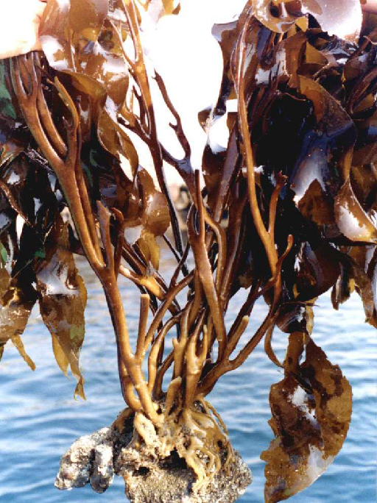**Lessonia trabeculata (LETR)**

**UPC, QUAD, MORPHOMETRICS**

**Lessonia juvenile (LEJ)**

**<20cm**

**UPC, QUAD, MORPHOMETRICS**



**Macrocystis sp. (MASP)**

**Giant Kelp**

**UPC, QUAD**

**Macrocystis juvenile (MAJ)**

**Giant Kelp Juveniles**

**<20cm**

**UPC, QUAD**